Project Name

Students :Liora Szuchmahcer Huf
Eddy Sraiber
Supervisor : Goel Samuel
Semester : Aviv 2020

Project Description :
The K means algorithm is an iterative algorithm which divides a given data vector to K different clusters (K is a natural number). Each cluster will be characterized by its “center of mass”, what is referred to as centroid.

Universal Verification Methodology (or UVM) is a methodology for functional verification of integrated circuits. UVM is based on the OVM (Open Verification Methodology) and has its own supporting library of SystemVerilog code.
UVM is a tool which enables automatic execution of central parts of verification process of VLSI circuits.

The goal of this project is to design and implement an UVM based verification process for an IP name “K means” which performs the k means algorithm.
Project Requirements:
- UVM methodology study
- Building UVM classes
- Building a Reference model
- Running simulations and fixing bugs of the IP
Project Specifications:
- Using UVM Methodology for the verification environment
- Define and implement a test plan to test all legal scenarios
- Check all types of coverages (line, condition, FSM, toggle and functional coverages). The goal is to reach 100% coverage for each type.
- Implement a reference module to compare with DUT.
- Correct DUT bugs

Development Stages / Design Flow | Tools
Software Simulation(Reference model) | Matlab
Architectural and Logic Design
HDL Implementation | System Verilog
Functional simulation | System Verilog

Literature
UVM experience guide from Technion course

Alternative solutions
Verification is an essential part of VLSI circuits design, usually done thought simulations. In order to ensure correct functionality of the design, there is a need to check correct functionality for all possible legal inputs of the circuit. Creating all possible inputs can be a time consuming task , and in some cases, even impossible. Therefore, the verification engineer needs to have parameters which show how much of the design the simulations verified. Doing this with regular tools (such as Verilog testbenches) is hard.

Selected solution
The UVM is a tool which was developed specific for the purpose of verification, been able to overcome many of the obstacles describe in the previous section. Therefore, the verification of the “K means” IP will be done using it.

Top Level Interface(“K means” IP)
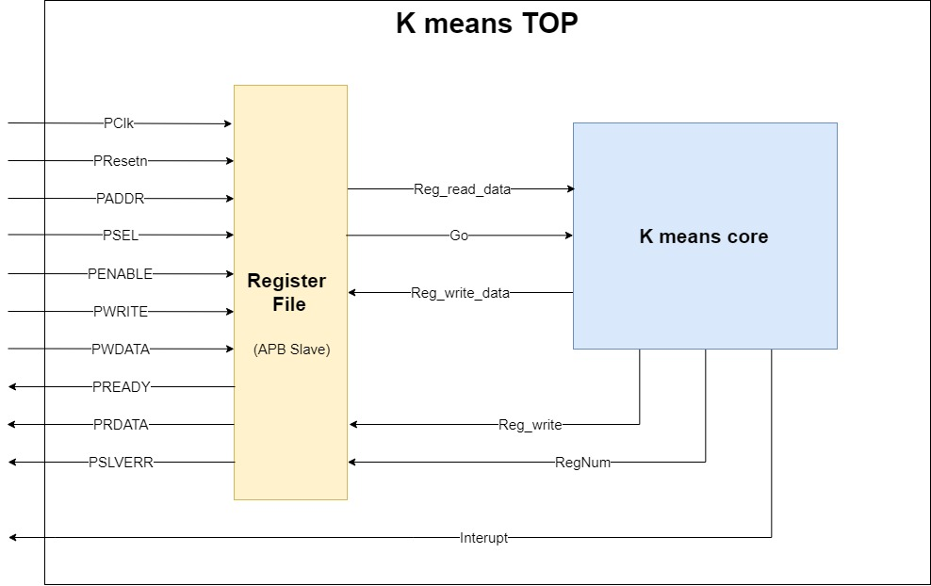

Top Level Architecture

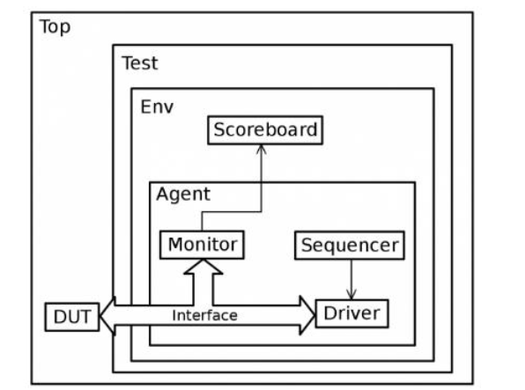

Provisional/Preliminary Schedule  UVM methodology studies  Building reference model in matlab  Building UVM classes  Simulations and bug fixes  Project report | Week  1-3  3-5  6-10  10-12  12-14

Please prepare a Gantt chart as follows: Gantt Chart Example:
Week 1 2 3 4 5 6 7 8 9 10 11 12 13 14 15
UVM methodology studies

Building reference model in matlab

Building UVM classes

Simulations and bug fixes

Report

